INSTALANDO NETBEANS

Descargar Netbeans de la pagina oficial

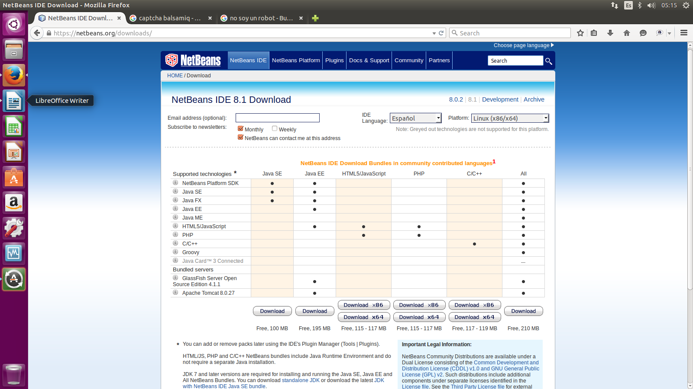

Installing Oracle JDK
In this section, you will need sudo privileges:
sudo su
The /opt directory is reserved for all the software and add-on packages that are not part of the default installation. Create a directory for your JDK installation:
mkdir /opt/jdk
and extract java into the /opt/jdk directory:
tar -zxf jdk-8u5-linux-x64.tar.gz -C /opt/jdk
Verify that the file has been extracted into the /opt/jdk directory.
ls /opt/jdk

Setting Oracle JDK as the default JVM
In our case, the java executable is located under /opt/jdk/jdk1.8.0_05/bin/java . To set it as the default JVM in your machine run:
update-alternatives --install /usr/bin/java java /opt/jdk/jdk1.8.0_05/bin/java 100
and
update-alternatives --install /usr/bin/javac javac /opt/jdk/jdk1.8.0_05/bin/javac 100

Verify your installation
Verify that java has been successfully configured by running:
update-alternatives --display java
and
update-alternatives --display javac
The output should look like this:
java - auto mode
link currently points to /opt/jdk/jdk1.8.0_05/bin/java
/opt/jdk/jdk1.8.0_05/bin/java - priority 100
Current 'best' version is '/opt/jdk/jdk1.8.0_05/bin/java'.

javac - auto mode
link currently points to /opt/jdk/jdk1.8.0_05/bin/javac
/opt/jdk/jdk1.8.0_05/bin/javac - priority 100
Current 'best' version is '/opt/jdk/jdk1.8.0_05/bin/javac'.
Another easy way to check your installation is:
java -version
The output should look like this:
java version "1.8.0_05"
Java(TM) SE Runtime Environment (build 1.8.0_05-b13)
Java HotSpot(TM) 64-Bit Server VM (build 25.5-b02, mixed mode)

Instalando NetBeans

Luego con el comando cd localizan el archivo, tal y como hicieron con el .tar.gz del JDK, entonces, una vez localizado el .sh hay que darle permisos de ejecución
chmod 755 archivoInstalador.sh
para poder ejecutar el archivo con el comando sh, así:
sh archivoInstalador.sh

